# Fall 2022 Data Science Intern Challenge

Please complete the following questions, and provide your thought process/work. You can attach your work in a text file, link, etc. on the application page. Please ensure answers are easily visible for reviewers!

**Question 1:** Given some sample data, write a program to answer the following: [click here to access the required data set](https://docs.google.com/spreadsheets/d/16i38oonuX1y1g7C_UAmiK9GkY7cS-64DfiDMNiR41LM/edit#gid=0)

On Shopify, we have exactly 100 sneaker shops, and each of these shops sells only one model of shoe. We want to do some analysis of the average order value (AOV). When we look at orders data over a 30 day window, we naively calculate an AOV of $3145.13. Given that we know these shops are selling sneakers, a relatively affordable item, something seems wrong with our analysis.

1. Think about what could be going wrong with our calculation. Think about a better way to evaluate this data.
2. What metric would you report for this dataset?
3. What is its value?

**Solution 1** :  
Collab Notebook Link : - <https://colab.research.google.com/drive/1A8FZ9-H3XJ0DFvuGyRuX3-e3UFLfxs2I?usp=sharing>

**Question 2:** For this question you’ll need to use SQL. [Follow this link](https://www.w3schools.com/SQL/TRYSQL.ASP?FILENAME=TRYSQL_SELECT_ALL) to access the data set required for the challenge. Please use queries to answer the following questions. Paste your queries along with your final numerical answers below.

**Solution 2 :**

1. How many orders were shipped by Speedy Express in total?

**Query :**   
SELECT s.ShipperName,count(*)

FROM Orders o

JOIN Shippers s

ON s.ShipperID = o.ShipperID

GROUP BY s.ShipperName

HAVING s.ShipperName = 'Speedy Express';

<<<<<<<<<<<<<<<< or >>>>>>>>>>>>>>>>>

SELECT count(*)

FROM Orders o

WHERE o.ShipperID =

( SELECT s.ShipperID

FROM Shippers s

WHERE s.ShipperName = 'Speedy Express');

**Result : 54**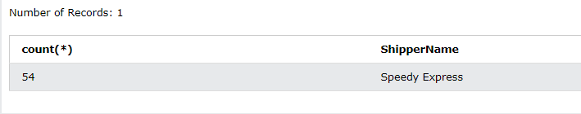

Note : Since we need to find the value of total orders by Speedy Express, option 2 is a better query as it does not involve JOIN, thus less computation.

1. What is the last name of the employee with the most orders?

**Query:**

SELECT MAX(OrderCount) as Max, lastname

FROM

(SELECT e.lastname,count(*) as OrderCount

FROM Orders o

JOIN Employees e

ON e.EmployeeID = o.EmployeeID

GROUP BY e.EmployeeID);

**Result: Peacock**  
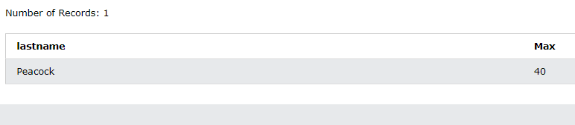

1. What product was ordered the most by customers in Germany?  
   **Query:**

SELECT ProductName,max(countProd)

FROM

(SELECT p.ProductName, count(*) as countProd

FROM Orders o

JOIN Customers c

ON o.CustomerId = c.CustomerId

JOIN OrderDetails d

ON o.orderID = d.orderID

JOIN Products p

ON p.productID = d.productID

WHERE c.country = "Germany"

GROUP BY d.productID)

<<<<<<<<<<<<<<<< or >>>>>>>>>>>>>>>>>

SELECT * FROM

(SELECT p.ProductName, count(*) as countProd

FROM Orders o

JOIN Customers c

ON o.CustomerId = c.CustomerId

JOIN OrderDetails d

ON o.orderID = d.orderID

JOIN Products p

ON p.productID = d.productID

WHERE c.country = "Germany"

GROUP BY d.productID

ORDER BY countProd DESC)

LIMIT 1

**Result: Gorgonzola Telino**  
